Contact Augmented Reality:   
Exploring its Design and Implementation

|  |  |  |
| --- | --- | --- |
| 1st Author Name  Affiliation  Address  e-mail address  Optional phone number | 2nd Author Name  Affiliation  Address  e-mail address  Optional phone number | 3rd Author Name  Affiliation  Address  e-mail address  Optional phone number |

# ABSTRACT

Permission to make digital or hard copies of all or part of this work for personal or classroom use is granted without fee provided that copies are not made or distributed for profit or commercial advantage and that copies

bear this notice and the full citation on the first page. To copy otherwise, or republish, to post on servers or to redistribute to lists, requires prior specific permission and/or a fee.

We present Contact Augmented Reality (cAR), an approach to augmented reality where the display is mobile and on direct contact with the augmented object.

## Author Keywords

## ACM Classification Keywords

## General Terms

# INTRODUCTION

Augmented reality (AR) enhances the real world by embed-ding digital content onto it. At the basic level, AR faces challenges in terms of display technology, registration and rendering [2]. The display type used determines the interaction possibilities and the complexity of registration and rendering. Traditional AR relies on mobile displays carried by the users (retinal, HMDs, smartphones and handheld projectors), allowing the augmentation of virtual-ly any object within the display’s field-of-view but requi-ring complex operations for registration (e.g. 3D location, object recognition) and rendering (e.g. field-of-view calcu-lation, perspective correction). Further, mobile displays pre-sent limitations in terms of resolution, focus, lighting and comfort. On the other side, spatial augmented reality (SAR) relies on displays fixed in the environment (projections, transparent LCDs); requiring simpler operations for regis-tration and rendering and offering solutions to the limita-tions of traditional AR, but limited to non-mobile appli-cations [2].

In this paper we present Contact Augmented Reality (cAR), an approach to augmented reality which builds on the strengths of SAR while preserving the vision of an AR that is mobile. The basic tenet of cAR is a *mobile device* with a *portable transparent display* (e.g. TOLED) that augments a physical object when *in direct contact with it*. This direct contact provides spatial alignment at a very short distance 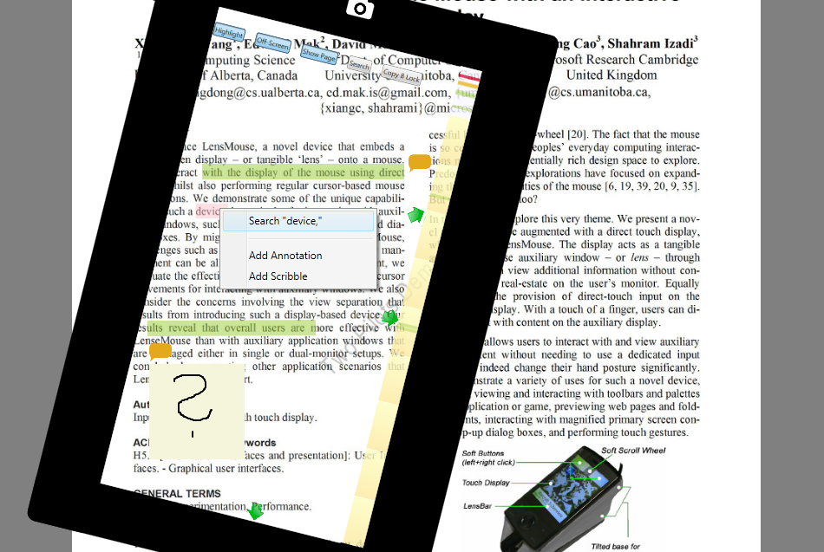

Figure 1: tPad screen capture showing highlights (green) , text and free-hand annotations, and off-screen pointers (arrow).

between the digital content and the augmented object, thus simplifying registration and rendering: registration is reduced to finding the *relative* 2D location and orientation of the cAR device on-top of the augmented object; rendering no longer requires perspective corrections.

By following an iterative and user-centric design approach, and taking Active Reading as a sample application area [1], we built a series of prototypes which helped us identified and explore a series of interaction techniques for cAR devi-ces. We divide such techniques into contact-based (e.g. an-notations, scribbles), content-aware (e.g. UI orientation, content lookup), and off-contact (e.g. flipping, stacking) interaction techniques.

Our final prototype is a mobile device called the tPad. The tPad addresses the registration problem by using a camera-based feature tracking approach, and uses a capacity-overlay for touch input; a controller board detects the tPad's flipping or whether it's stacked with another one. We implemented the ActiveReader (see Figure 1), a tPad application that allows users to underline, highlight, scrib-ble comments, search content, and look-up references (see Figure 1). Users access special information by flipping the tPad, and two tPads can share content when staked-up.

We studied the ActiveReader tPad application with users in active reading tasks. The tasks required using all the tPad features like touch, flipping and staking. Initial feedback shows that using the tPad is highly intuitive and learn-able. Moreover, users highlighted the value of reading on paper, having the digital features when needed, and being able to access their annotations digitally.

Our contributions are at the conceptual, interaction design, and technical levels. First, we introduce cAR and differen-tiate it from existing AR approaches. Second, and propose a series of interaction techniques for cAR. Finally, we present a device prototype called the tPad and show how the tPad and the CAR notion can be applied to and benefit an every-day task such as active reading.

# RELATED WORK

### Augmented Reality

HMDs and Handheld

### Spatial Augmented Reality

Fixed in relation to the object

Projectors, transparent displays

### Virtual Lenses

Mackays ABook – say that we were inspired by this work and we generalize this initial exploration into the concept of cAR. However, we depart in several ways: first we use a camera based registration, second we explore off-contact and content-aware interactions, third we rely on transparent display technology.

# Contact Augmented Reality - cAR

Definition: mobile device which augments when coming in close contact (overlay) with the augmented surface.

How is cAR different than traditional or spatial? 1) Activated upon contact, else the device works as a normal mobile device 🡪 it is not handheld as it needs the surface.

2) Spatially aligned -> registration problem is reduced to finding the location of the device in relation to the surface, no need to track the user.

3) Interaction techniques that are contact-based, content-aware, and off-contact (like a normal mobile device).

Why does it need a transparent display: 1) because it preserves the appearance (texture, colors, lighting, age, wear) of the object being augmented.

2) Because if maintains visible the physical modifications done in that object.

# Approach

We used Active Reading as an application scenario and an inspiration tool to brainstorm and elicit features and interaction techniques.

Design sessions

Prototype 1 - Tabletop

Prototype 2 – tPad

# cAR Interaction Techniques

Contact-based

Content-aware

Off-Contact

# Tabletop Prototype

Implementation Details: registration, display and render details.

Features

Feedback

Limitations

# tPad Prototype

Implementation Details: registration, display and render details.

Features – features that are not contact, reinforce the need of paper

Feedback

Limitations: LCD and light-table, FPS, single-side touch input, attached to the computer

# Discussion

Transparent displays on mobile devices – perhaps not for mobile phones, but convenient for cAR.

Model-based registration: model creation and distribution

Model-based –vs– ad-hoc registration

# Conclusions

Actual conclusions

Future work

# REFERENCES

1. Adler, M. J. and Van Doren, C. How to Read a Book. Revised edition, Simon and Schuster, New York, 1972.
2. Bimber, O. and Raskar, R. 2005. Spatial Augmented Reality: Merging Real and Virtual Worlds. A. K. Peters, Ltd., Natick, MA, USA.
3. Doshi, OR A., Cheng, S. Y., and Trivedi, M. M. 2009. A novel active heads-up display for driver assistance, IEEE Trans. Syst., Man, Cybern. B, Cybern., vol. 39, no. 1, pp. 85–93, Feb. 2009.
4. Japan’s transparent display vending machine. <http://techcrunch.com/2011/12/20/video-japan-vending-machine-2-0/>
5. Karnik, A., Mayol-Cuevas, W. and Subramanian, A. 2011. MUST-D: multi-user see through display. In Proceedings of the 24th annual ACM symposium adjunct on User interface software and technology (UIST '11 Adjunct). ACM, New York, NY, USA, 77-78.

**The columns on the last page should be of approximately equal length.   
Remove these two lines from your final version.**